The Dataset came from [Fast Food Nutrients](https://www.kaggle.com/datasets/joebeachcapital/fast-food) from Kaggle. It contains 1,148 rows with 14 columns. The goal is to use Bayesian Linear Regression to predict the calories.

***Please see jupyter notebook for full EDA and modeling***

**Calorie Count**

**Burgers and Shakes Are the Biggest Calorie Bombs**: Fast food items exceeding 1100 calories are mainly giant burgers or large shakes.

**Drinks Can Be as Bad as Meals**: A 32 oz McDonald’s shake has almost as many calories as a Triple Whopper.

**Breakfasts Are Heavy Too**: McDonald’s Big Breakfast with Hotcakes is one of the most caloric meals available.

Based from **Total calories, Fat, Sodium and Trans Fat, *Burger king***is the Worst offender

**Fast Food “Nutrients” vs Daily Limit** by consuming single item an average person already hit “nutrition limit”

|  |  |  |  |
| --- | --- | --- | --- |
| **Nutrient** | **Daily Limit** | **Worst Offender (Item & Company)** | **Value** |
| Calories | 2000 kcal | Triple Whopper® w/ Cheese (BurgerKing) | 1220 kcal (61% of daily limit) |
| Total Fat | 70g | Potato Salad (Family) (KFC) | 98g (140% over limit) |
| Sodium | 2300mg | Secret Recipe Fries (Family) (KFC) | 2890mg (125% over limit) |
| Carbs | 275g | Strawberry Lemonade (1/2 Gallon) (KFC) | 270g (98% of limit) |
| Protein | 50g | Triple Whopper® w/ Cheese (Burger King) | 71g (142% over limit) |

**Company level insights (Highest per nutrient average)**

|  |  |
| --- | --- |
| **Calories** | Burger King: 359 kcal per item |
| **Sodium content** | Burger King: 540 mg (very high sodium levels) |
| **Fat** | Burger King: 16.6g per item |
| **Highest Sugar Content (g)** | McDonald’s: 28.1g per item (highest sugar levels) |

**Nutrient Correlation**

|  |  |  |
| --- | --- | --- |
| **Nutrient Pair** | **Correlation Strength** | **Key Insight** |
| Calories & Fat | Strong (0.83) | Higher fat = higher calories, but sugary items (sodas, shakes) can be exceptions. |
| Calories & Sodium | High (0.73) | High-calorie foods tend to be high in sodium, likely due to processed ingredients. |
| Fat & Sodium | Strong (0.81) | Fatty foods are often salt-heavy (e.g., fried chicken, burgers). |
| Calories & Sugars | Weak (0.26) | Sugary items (shakes, sodas) are calorie-dense but don’t always have fat. |
| Fat & Sugars | Negative (-0.23) | High-fat foods (burgers) usually don’t have much sugar, while high-sugar items (soft drinks) are often fat-free. |
| Calories & Protein | Moderate (0.73) | Higher protein often means more calories, but sources matter (grilled vs. fried chicken). |

**Features to extract**

Utilized random forest from sklearn to identify features

[Protein, Saturated Fat, Sodium, Carbs, and Total Fat] that heavily influences our target variable (calories) and checked for their possible Linear relationship.

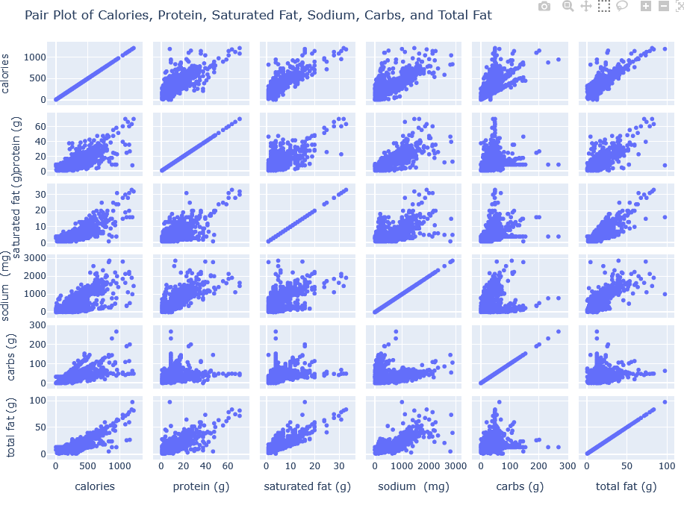

Using Simple Linear Regression, the coefficient of each feature selected are extracted and showed that Carbs has the most impact with **0.67** while Protein is the lowest

|  |  |
| --- | --- |
| **Feature** | **Coef.Weight** |
| Carbs | 0.67 |
| Total Fat | 0.46 |
| Sodium | 0.27 |
| Saturated Fat | 0.22 |
| Protein | 0.11 |

The following are metrics from the linear regression vs linear regression with MCMC

|  |  |  |
| --- | --- | --- |
| **Metric** | **Linear Regression** | **Linear Regression with MCMC** |
| R² Score | 0.8913 | 0.9020 |
| MAE | 0.4849 | 0.4525 |
| MSE | 0.0037 | 0.0028 |
| RMSE | 0.0605 | 0.0532 |

The Linear Regression with MCMC outperforms standard Linear Regression across all metrics, the LR-MCMC has more predictive accuracy and robustness. This indicates that MCMC improves parameter estimation that results to a bit more reliable model.

This is just a context on what is the FDA approve limit per nutrient

|  |  |  |
| --- | --- | --- |
| Nutrient | FDA Daily Limit | Estimated Per-Item Limit (1 meal = ~⅓ of daily intake) |
| Calories | 2,000 kcal | ~667 kcal per meal |
| Total Fat | 78g (35% of daily calories) | ~26g per meal |
| Saturated Fat | 20g | ~7g per meal |
| Trans Fat | 0g (should be avoided) | 0g per meal |
| Cholesterol | 300mg | ~100mg per meal |
| Sodium | 2,300mg | ~767mg per meal |
| Carbohydrates | 275g (55% of daily intake) | ~92g per meal |
| Fiber | 28g | ~9g per meal |
| Sugars | 50g (added sugars) | ~17g per meal |
| Protein | 50g | ~17g per meal |